**Model – BM 1.0**

**User Manual**



**Master Bell System – Key Features**

* Automatic Daily Bell Scheduling
* Supports up to 20 programmable bell times per day.
* Custom Track Playback
* Each bell can play a unique MP3 track from USB or SD card.
* Track selection via track code (001 to 099) matching audio file name (e.g., 001.mp3).
* Repeat Count Setting
* User-defined repeat count for each bell (minimum 1 repeat).
* Real-Time Clock (RTC)
* Built-in DS3231 RTC for accurate and consistent timekeeping, even during power failures.
* EEPROM Memory Storage
* Stores all bell times, track codes, and settings permanently—no data loss on power off.
* User-Friendly Interface
* Easy navigation using UP, DOWN, LEFT, RIGHT buttons.
* Settings displayed on 16x2 LCD screen with blinking area for editing.
* Built-in Audio Amplifier
* Powered by a 24V 2.5A supply, driving external speakers (SPK1 & SPK2 terminals).
* Optional line-out for external amplifier connection.
* Multiple Output Options
* Connect speakers directly via SPK1/SPK2 or route audio to external amp.
* USB/SD Card Compatible
* Supports FAT32-formatted USB drives/SD cards, plug & play.
* Manual Control Option
* Optional manual trigger for instant bell or test play.
* Reliable and Durable Design
* Operates in 0°C to 50°C environment, ideal for schools, colleges, and institutions.
* Compact, wall-mountable enclosure with power safety feature

22VAC

SPK2

SPK1

LCD Display

Volume Control

USB Drive Connection

**Audio Output for External Amplifier**

Amplifier Volume Control knob

Main Switch

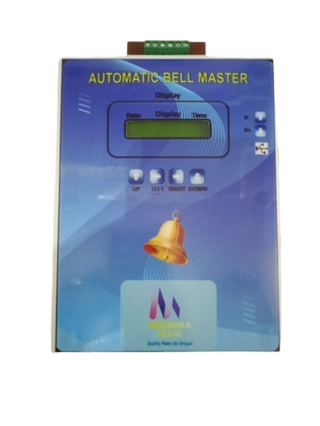

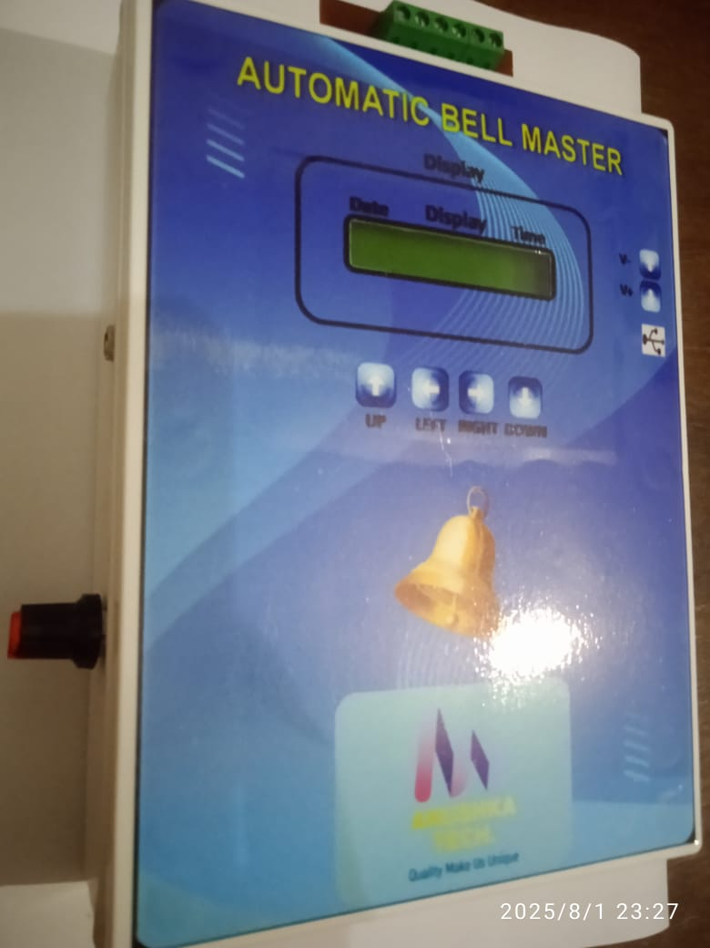

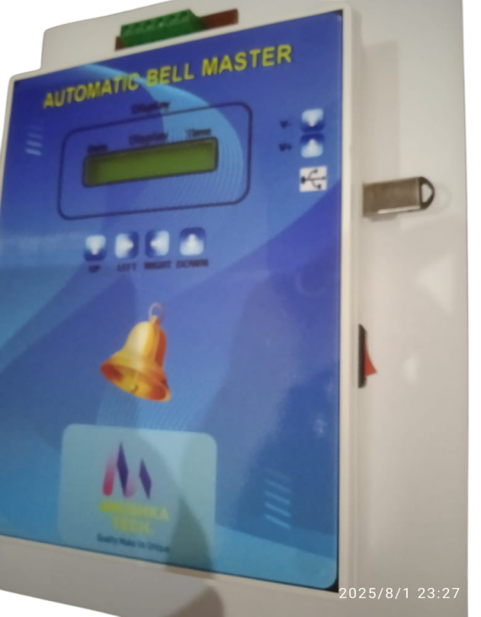

Push Button for Setting and Navigate through Menu

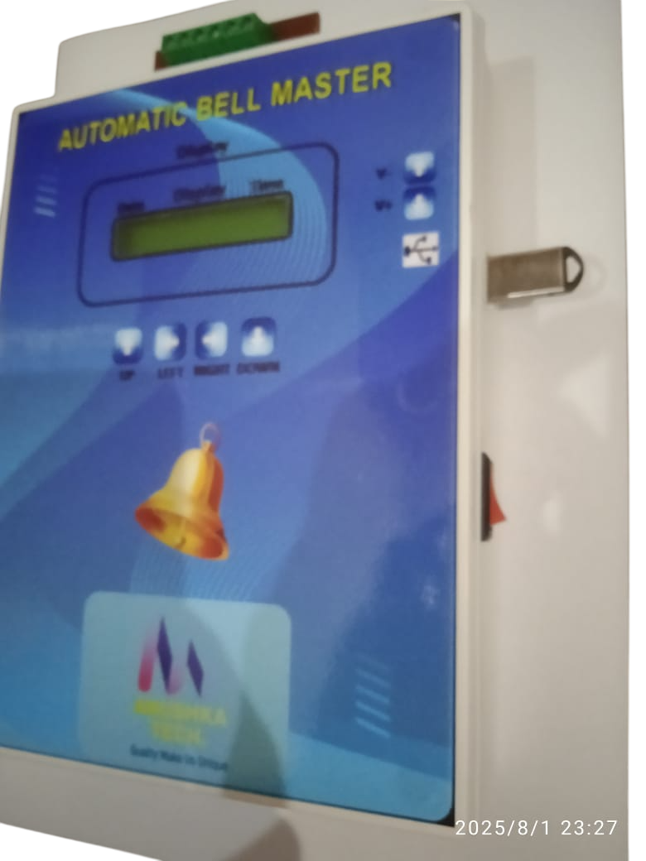



**Mains Switch:**  
Use the mains switch to turn the entire system ON or OFF. Ensure the switch is in the OFF position before performing any maintenance or installation activities.

**Switch on device and wait for (Approx 2 to 3 second) for initialization.**

**Navigation and Setting Key (Push Button):**

Use the **UP, DOWN, LEFT**, and **RIGHT** buttons to navigate through the menu options and change settings:

**UP/DOWN**: Scroll through menu items or increase/decrease values.

**LEFT/RIGHT**: Move between settings fields or toggle between options.

**Audio Output for External Amplifier:**

This device provides a **line-level audio output** for connection to an external amplifier. Use a **3.5mm stereo jack** or **RCA connectors** (as applicable) to connect the audio output to the amplifier’s input. Ensure the amplifier is powered off during connection to avoid noise or damage.

**Note: This is not a speaker-level output. Connect only to amplifier input, not directly to speakers.**

**Volume Control Knob:**

Use the **Volume Control Knob** to adjust the output sound level of the amplifier. Turn the knob **clockwise** to increase the volume and **counter clockwise** to decrease it.

**Note: set the volume to a low level before powering on the amplifier to avoid sudden loud output.**

**Volume Control Push Button:**

Use the **Volume Control button** to adjust the output sound level of audio level output.

**USB Drive Connection:**

Insert a **USB flash drive** into the **USB port** to play audio files directly. The system supports **MP3** and other common audio formats.  
Once connected, the device will automatically detect the drive and begin playback. Use the navigation buttons to browse tracks if supported.

**Note: Use only standard USB drives (FAT32 format) up to 32GB for best compatibility. Do not remove the USB drive while playing.**

**SPK1 and SPK2 Terminals:**

Connect external speakers to the **SPK1** and **SPK2** terminals. These are **outputs** from the built-in amplifier.

Ensure speaker impedance is **8Ω**.(MAX watt 50W)

Connect the speaker wires firmly: **positive (+)** to **+ terminal** and **negative (–)** to **– terminal** on each speaker.

**Note: Power off the system before connecting or disconnecting speakers to avoid damage.**

**220V AC Power Input Terminal:**

Connect the device to a **220V AC mains supply** using the designated terminal block. Ensure correct wiring:

**Note: Always disconnect the power before wiring.  
Note: Only qualified personnel should handle AC connections to avoid the risk of electric shock.**

**Menu Navigation and Setting**:

1. Press left button for System Setting
2. 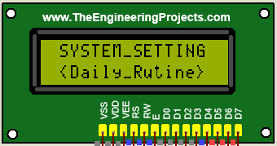Use the navigation buttons (UP/DOWN) to scroll through Menu and right button for selection.

**Track Code**

A- **Daily Routing:**

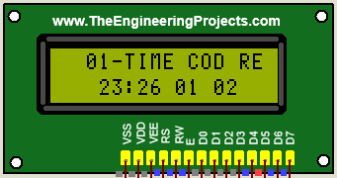**Bell Time & Track Setup Instructions:**

**Time: HH:MM**

**Repeat Count**

Use the navigation buttons (**UP/DOWN**) to change the value in the **blinking area**.   
After setting the value, press the **RIGHT** button to **save the selection**.

For each bell:

Select a **track code** (e.g., 001 to 099) that matches the audio file stored in the USB or SD card.

Set a **track repeat count** if needed. The **minimum repeat count** should be **1**.

**Note: Ensure all track files (e.g., 001.mp3, 002.mp3) are properly named and located in the root directory of the USB/SD card.**

Bells will automatically ring at the scheduled times with the selected track.

You can set up to **20 bells** per day, each with a custom time and associated track code and repeat count

**B- Special Date:**

Select the spacial date setting menu from the list.

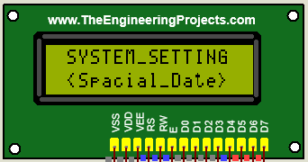

Use the navigation buttons (**UP/DOWN**) to change the value in the **blinking area**.

After setting the value, press the **RIGHT** button to **save the selection**.

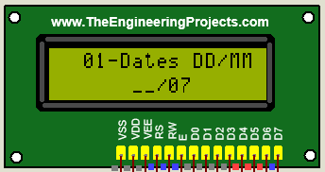

Special Date: Date/Month

You can set up to **10 date** max, which have different schedule from the normal days.

**C- Special Bell:**

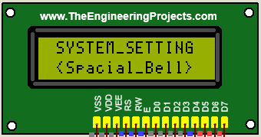Select the spacial Bell setting menu from the list.

Use the navigation buttons (**UP/DOWN**) to change the value in the **blinking area**.

After setting the value, press the **RIGHT** button to **save the selection**.

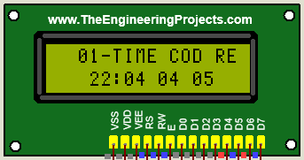

Repeat Count

Special Bell time: HH:MM

Track Code

You can set up to **10 Bell** max, which have different schedule from the normal days.

**D- Week Day and Week off Selection Setting:**

Select the System Day setting menu from the list.

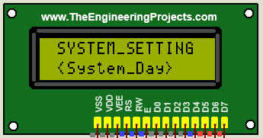

Use the navigation buttons (**UP/DOWN**) to change the value in the **blinking area**.

After setting the value, press the **Left** button to **save the selection**.

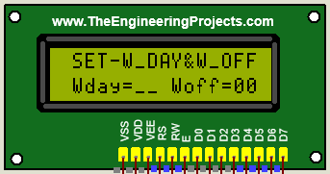

Week of the Day Setting:

1-Monday

2-Tuesday

3-Wednesday

4-Thursday

5-Friday

6-Saturday

7-Sunday

Week of the Day Setting:

1. Monday
2. Tuesday
3. Wednesday
4. Thursday
5. Friday
6. Saturday
7. Sunday

**Note: Set corresponding digit (1-7) for week of day and Week off selection.**

**E- System Time:**

Select the System Time setting menu from the list.

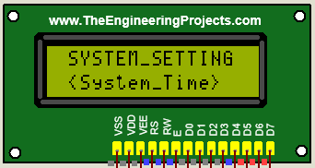

Use the navigation buttons (**UP/DOWN**) to change the value in the **blinking area**.

After setting the value, press the **Left** button to **save the selection**.

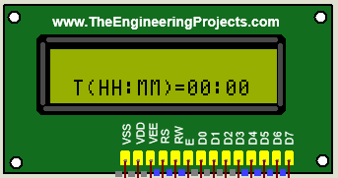

**E- System Date:**

Select the System Time setting menu from the list

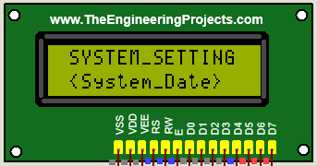

Use the navigation buttons (**UP/DOWN**) to change the value in the **blinking area**.

After setting the value, press the **Left** button to **save the selection**.

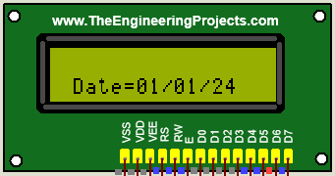

|  |  |  |  |  |  |  |
| --- | --- | --- | --- | --- | --- | --- |
| **Track Name** | **Code** | **Entry Code** |  | **Track Name** | **Code** | **Entry Code** |
| **0000-Zeroth-Period** | **0000** | **01** |  | **0013-Thirteen-period** | **0013** | **14** |
| **0001-Frist-period** | **0001** | **02** |  | **0014-Fourteen-period** | **0014** | **15** |
| **0002-Second-period** | **0002** | **03** |  | **0015-Fifteen-period** | **0015** | **16** |
| **0003-Third-period** | **0003** | **04** |  | **0016-Assembly** | **0016** | **16** |
| **0004-Fourth-period** | **0004** | **05** |  | **0017-lunch-time** | **0017** | **17** |
| **0005-Fifth-period** | **0005** | **06** |  | **0018-School-Close** | **0018** | **18** |
| **0006-Sixth-period** | **0006** | **07** |  | **0019-EGB** | **0019** | **19** |
| **0007-Seventh-period** | **0007** | **08** |  | **0020-Gong-Bell** | **0020** | **20** |
| **0008-Eight-period** | **0008** | **09** |  | **0021-Siren** | **0021** | **21** |
| **0009-Ninth-period** | **0009** | **10** |  | **0022-Jana-Gana-Mana** | **0022** | **22** |
| **0010-Tenth-period** | **0010** | **11** |  | **0023-Vande Mataram** | **0023** | **23** |
| **0011-Eleventh-period** | **0011** | **12** |  |  |  |  |
| **0012-Twelve-period** | **0012** | **13** |  |  |  |  |

**Specifications:**

|  |  |
| --- | --- |
| Power Supply | 220V AC input (internal 24V DC, 2.5A regulated for amplifier) |
| Bell Output | Audio output via built-in amplifier (up to 50W total) |
| Speaker Output Terminals | SPK1 and SPK2 , 4–8Ω compatible |
| Audio Source | USB Drive / SD Card (supports MP3 format, 001.mp3 to 099.mp3) |
| Track Selection | Individual track code (001–099) per bell schedule |
| Track Repeat Option | Selectable repeat count per bell (min. 1 time) |
| Number of Bells | Up to 20 bell times per day |
| Real-Time Clock (RTC) | DS3231 high-accuracy timekeeping module |
| Memory Backup | EEPROM storage for all bell schedules and settings |
| Display | 16x2 LCD for time and menu navigation |
| Navigation Buttons | UP, DOWN, LEFT, RIGHT for setting time and bell schedules |
| Output for External Amp | Line-level audio out (optional) |
| Enclosure | Wall-mountable, metal/plastic casing (customizable) |
| Operating Temperature | 0°C to 50°C |
| Dimensions | [8X6X2.5]inches |
| Weight | [400]gram |

**Anushka Tech**.

**Customer Support +91-8840675624**

**Email:mohan.sharma2004@gmail.com**

